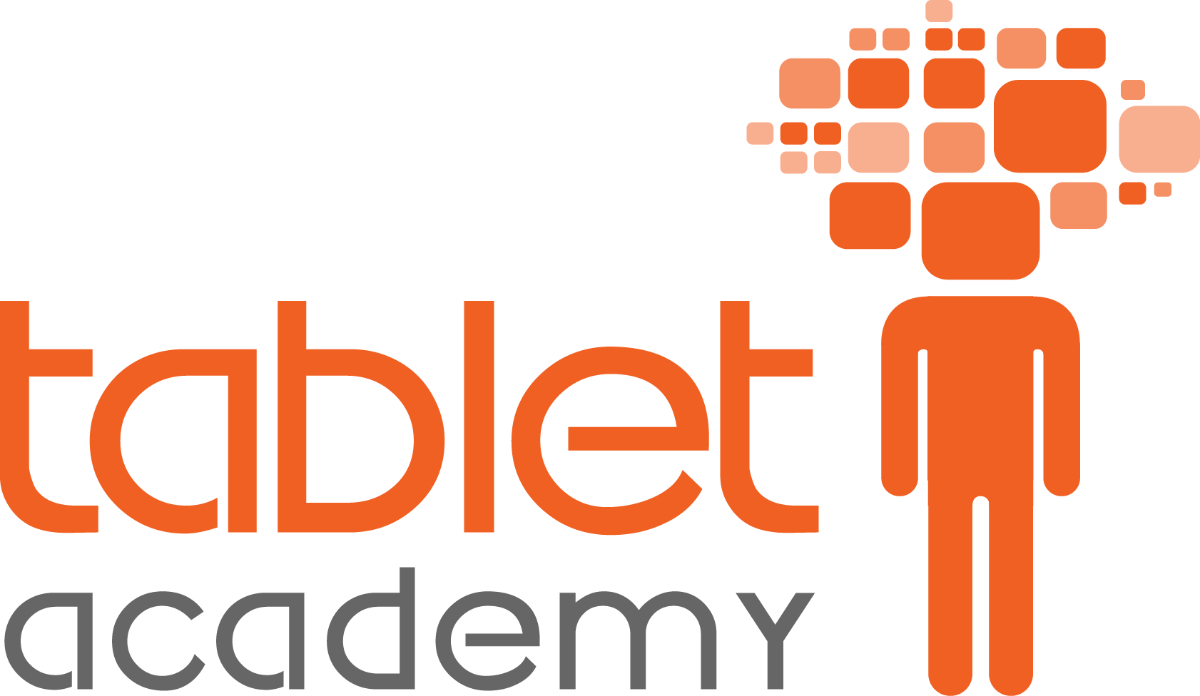

2016 Industry Funded CPD Offer

Prepared by Mark Yorke
24th May 2016

Introduction

Many schools purchase new devices for teachers and student to use in the classroom, but few consider the impact this will have on teaching and learning. Experience shows us that teachers need support to identify how new technologies can enhance lessons or improve engagement.

Based on this theory, working with Microsoft we are introducing a pilot programme that provides schools with funded face-to-face training when they purchase a certain number of devices.

The following document provides an outline of training courses schools can claim when purchasing a certain number of devices.

These are courses that demonstrate tools that can be applied in all subject areas for primary, secondary, further and higher education. Bespoke programmes are also available upon request.

The focus of the training is to embed the use of technology into lessons, we focus on how the solutions can be utilised in the classroom. It is training designed for teachers and classroom practitioners. It is not technical training.

Who are Tablet Academy?

Tablet Academy is a platform agnostic independent organisation created to support educational institutions in transforming teaching and learning through the integration of new and existing technologies.

Through consultancy and training services, their team of experienced teachers are working to close the gap between the classroom and the ideology promoted by the 'Ed-Tech' industry.

As educators from both the state and independent sector, their experience of supporting over 600 schools and training more than 12,000 teachers per annum helps them understand how schools work, and the pressures they face. This is why they focus on developing people and do not focus on the technology.

Tablet Academy provides a wide range of services including hands-on training for teachers, experience days for pupils, independent advice for school leaders and evangelism events for its industry partners.

www.tablet-academy.com

The Rewards
Your organisation can only receive one instance of funded CPD and the value of this support is dependent on the number of devices you have purchased:

Schools purchasing: Reward equals: Value:
- 25 to 49 devices - Teacher Academy Subscription or Half day training - £300 (+Vat)
- 50 to 150 devices - Full day training - £600 (+Vat)
- 150+ devices - Full day training and Teacher Academy Subscription - £900 (+Vat)

Full day and Half day training
Schools claiming this reward can select from the course outlines provided on the following pages, or they can request a bespoke training course through discussions with Tablet Academy.

- A Half-day session is classed as up to 4 hours on-site including 30mins prior to the session start time.
- A Full day session is classed as up to 7 hours on-site including 30mins prior to the session start time.
- We recommend group sizes of 20 staff in training sessions but can accommodate more if unavoidable.
- A pre-training phone call or email exchange will be expected to finalise details for each training event.
- The training required must be delivered within 6 months from the date of purchase.

Teacher Academy Subscription
The Teacher Academy is a new initiative from Tablet Academy that enables schools to access ongoing Professional Development for an annual subscription fee of £300 (+VAT).

By joining the Teacher Academy, the institution can:

- Access a free place at all Tablet Academy training events.
- Host up to 4 bespoke training events for their staff.
- Host a Tablet Academy Learning Festival.
- Receive newsletters including industry news, case studies and teaching resources.
- Receive a certificate to display in school and a logo to include on school stationery.

More information about the Teacher Academy is available here https://sway.com/I14wraPs0UiYhzIF

Training Content
Schools can select from the course outlines provided or they can choose to plan a bespoke workshop through discussions with Tablet Academy. These sessions can include co-delivery of lessons, experience days for students and staff INSET.

Contact Us
If you have any questions, please contact us at 01952 567450 or email mark@tablet-academy.com.

Course Outlines
(Bespoke programmes are also available upon request)

Office 365 for the Classroom

Aims & Overview
Office 365 contains not only the newest versions of Word, Excel, PowerPoint and Outlook but a range of powerful tools for teaching and learning including the amazing potential of "the cloud". The aim of this course is to introduce participants to Office 365 outlining what it is and how teachers can use it in their lessons and also make their planning and preparation more efficient.

Prerequisites
Basic computer use - creating and saving documents, organising files.

Delivery
This course is designed to be "hands-on" and can be delivered as either a half day overview or full day covering the content in greater depth.

Content
The content covered can be adapted to the requirements and skills of the participants as agreed upon by a school.
Course outcomes could include:
- Understand what Office 365 is and basics of cloud computing
- Gain an overview of the key tools in Office 365 and how it differs from other versions of Office
- Navigate around applications in the web interface
- Use Outlook Web App to manage e-mail
- Use the Calendar to add appointments and manage meeting requests
- Understand the similarities and differences of Online and Desktop applications
- Open, save and share documents using OneDrive for Business with Word Online, Excel Online and PowerPoint Online
- Save files from desktop Office applications to OneDrive for Business
- Use Online and Desktop applications for collaboration, review and to provide feedback
- Utilising OneNote as a digital notebook
- Access and share files using in Sites
- Participate and host communication via text, audio and video and present content using Skype for Business
- Post a contribution to a discussion in Yammer
- Find documents and create Boards using Delve
- Utilise Video for viewing and hosting videos

Using Office Mix & Sway to develop engaging learning materials

Aims & Overview
Most teachers know how to use PowerPoint and so they'll be excited to explore Office Mix - a free add-in from Microsoft, designed to give their presentations "super-powers"! In this course you will learn how to use Office Mix to develop online, interactive learning materials and explore how to use it with the "flipped classroom" approach. You will also discover the analytics for Mixes and how they can be used for assessment.
Sway is an easy to use yet powerful, web-based canvas for content that displays beautifully on screens of all sizes from a mobile phone through to a projector. We will show how Sway can be used by teachers to develop engaging learning materials and portfolios.

Prerequisites
Create and edit basic PowerPoint slideshows.

Delivery
This course is designed to be "hands-on" and can be delivered as either a half day overview or full day covering the content in greater depth.

Learning Outcomes
The content covered can be adapted to the requirements and skills of the participants as agreed upon by a school.
Course outcomes could include:
- Understand how to access and install Office Mix
- Locate and interact with Mixes in the Gallery
- Create a Mix from a PowerPoint presentation with inking, video, audio
- Insert quizzes, apps and other interactive elements into a Mix
- Understand publishing options and publish a Mix to the Mix website
- Review analytics for assessment
- Share Mixes with a range of different audiences
- Understand how Office Mix can be used for teaching and learning
- Review and present existing Sways
- Understand the key features of the Sway interface
- Create a Sway from scratch and by importing a document
- Enhance the Sway with designs styles and navigation elements
- Embed content from other sources
- Preview and share and collaborate with Sway
- Explore scenarios using Sway as a presentation tool and portfolio with students

Organising and Collaborating with OneNote

Aims & Overview
This workshop is designed for teachers to learn how to use OneNote as a digital notebook for capturing and organising notes, equations, to-do lists, images, photos, text, video, documents, audio and more. It also covers how this powerful tool can be used as a personal and collaborative notebook for a class of students and groups of teaching staff.

Prerequisites
Create and edit basic documents in Microsoft Word.

Delivery
This course is designed to be "hands-on" and can be delivered as either a half day overview or full day covering the content in greater depth.

Learning Outcomes
The content covered can be adapted to the requirements and skills of the participants as agreed upon by a school.
Course outcomes could include:
- Understand what OneNote is and an overview of the interface
- Take notes using text, inking, audio, video, images and more
- Capture research from the Web into a Notebook using a variety of tools and with referencing
- Collaborate with others using a shared notebook
- Create a OneNote Class Notebook to set up a shared notebook for a class of students
- Explore a range of scenarios to utilise OneNote for teaching and learning

Communicating and Collaborating with Yammer & Skype For Business

Aims & Overview
Yammer is a safe and secure social network that is integrated as part of Office 365. Students in the 21st century are often familiar with the use of social networks and Yammer allows teachers to harness their benefits they provide for communication and collaboration in a managed and controlled environment. Yammer has a multitude of applications to education which will be explored in scenarios throughout the course.
Skype for Business is a tool to communicate within a school and externally via text, audio and video. It is a powerful tool for communicating with others and hosting online lessons.

Prerequisites
Basic understanding of social networks e.g. Facebook, Twitter etc.

Delivery
This course is designed to be "hands-on" and can be delivered as either a half day overview or full day covering the content in greater depth.

Learning Outcomes
The content covered can be adapted to the requirements and skills of the participants as agreed upon by a school.
Course outcomes could include:
- Describe what Yammer is and understand its integration with Office 365
- Contribute to conversations and reply to threads
- Add polls and post feedback
- Create and administer Yammer groups
- Utilise Yammer in a variety of learning scenarios.
- Communicate using Skype for Business via text, audio and video
- Set up, schedule and participate in a Skype for Business conference all
- Host an online lesson with interactive elements e.g. Poll

